Name: Shriya Ramya Mohan Exp No: 2
Roll no: 241901106 Date : 19/8/2025

TCP CLIENT – SERVER USING SOCKET PROGRAMMING PYTHON

AIM:
To implement TCP client – server communication using socket programming in python.

INTRODUCTION
TCP echo application built with Python sockets. A server listens on localhost:55555, accepts a client connection, receives a text message, and echoes the same message back. The client connects to that server, sends the user’s message, and prints the server’s reply.
ALGORITHM - SERVER
- Call socket(AF_INET, SOCK_STREAM) to create a TCP/IPv4 socket.
- Bind the socket to ('localhost', 55555) so the OS routes incoming connections to this server.
- Call listen(3) to mark the socket as passive (backlog up to 3 queued connects).
- Accept a connection: clientfd, addr = accept().
- Receive data: read up to 1024 bytes from clientfd.
- Process/echo: print what arrived; send the exact bytes back to the client.
- Close client socket: after replying, close clientfd (so resources are freed).
- Operator prompt: ask the server operator whether to continue (y/n).
- Exit condition: if choice is 'n', break the loop.
• Shutdown
- Close the listening socket and end the program.

ALGORITHM – CLIENT
- Call socket(AF_INET, SOCK_STREAM) to create a TCP/IPv4 socket.
- Connect to the server at ('localhost', 55555).
- Prompt the user: “Enter your message”.
- Encode the string to bytes and send it on the socket.
- Read up to 1024 bytes from the server and decode to string.
- Print the echoed message.
- Close the socket and exit.

PROGRAM – CLIENT
import socket
sockfd=socket.socket(socket.AF_INET, socket.SOCK_STREAM)
print('Socket Created')
sockfd.bind(('localhost',55555))
sockfd.listen(3)
print('Waiting for connections')
while True:
clientfd,addr=sockfd.accept()
receivedMsg=clientfd.recv(1024).decode()
print("Connected with ",addr)
print("Message Received from Client: ",receivedMsg)
clientfd.send(bytes(receivedMsg,'utf-8'))
print("Message reply sent to Client!")
print("Do you want to continue(type y or n):")
choice=input()
if choice=='n':
break

PROGRAM – SERVER
import socket
clientfd=socket.socket(socket.AF_INET, socket.SOCK_STREAM)
clientfd.connect(('localhost',55555))
name=input("Enter your message:")
clientfd.send(bytes(name,'utf-8'))
print("Message Received from Server: ",clientfd.recv(1024).decode())

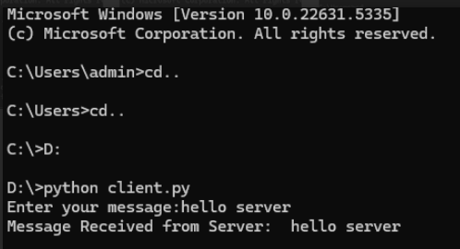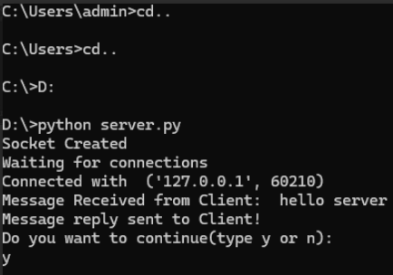
RESULTS:
Thus, TCP client-server communication was successfully implemented with python.

